

**BSC COMPUTING**

**COMP 1645**

**REQUIREMENTS ANALYSIS**

TABLE OF CONTENTS

INTRODUCTION 3

PART A - REQUIREMENTS ANALYSIS WITH RICH PICTURES 4

A1. RICH PICTURE OF THE COMPLETE NSSG ENVIRONMENT 4

A2. RICH PICTURE OF THE COMPLETE ELO ENVIRONMENT 5

A3. UNDERSTANDING OF NSSG OVERAL ENVIRONMET 6

A3.1. KEY ACTORS 6

A3.2. KEY ISSUES AND AREAS OF CONFLICT 7

A3.3. ORGANISATIONAL CULTURE AND SUB-CULTURES 8

A3.4. MAIN FOCUS OF REQUIRED SYSTEM 8

PART B – REQUIREMENTS ANALYSIS USING USE CASE MODELLING 9

B1. USE CASE DIAGRAM FOR ELO MANAGEMENT SYSTEM 9

B2. DOCUMENTING THE ELO USE CASE DIAGRAM 10

B2.1. PRIMARY SCENARIOS 10

B2.2. SECONDARY SCENARIOS 13

B3. DISCUSSING THE USE CASE MODELLING PROCESS. 18

PART C – CRITIQUE OF USE CASES AND RICH PICTURES 20

# INTRODUCTION

This report is focused on New Skill Set Gateway (NSSG), its activities and its profound partnership with Easy Learn Organization (ELO). NSSG is the largest skills training provider in the country. NSSG is used by most employers to provide training to their employees, its main focus is to provide and improve skills within the adult community through specialized classes offered at its 20 learning centers, online and through its partnership with ELO an organization specialized in Skills training for the adult community.

# PART A - REQUIREMENTS ANALYSIS WITH RICH PICTURES

## A1. RICH PICTURE OF THE COMPLETE NSSG ENVIRONMENT

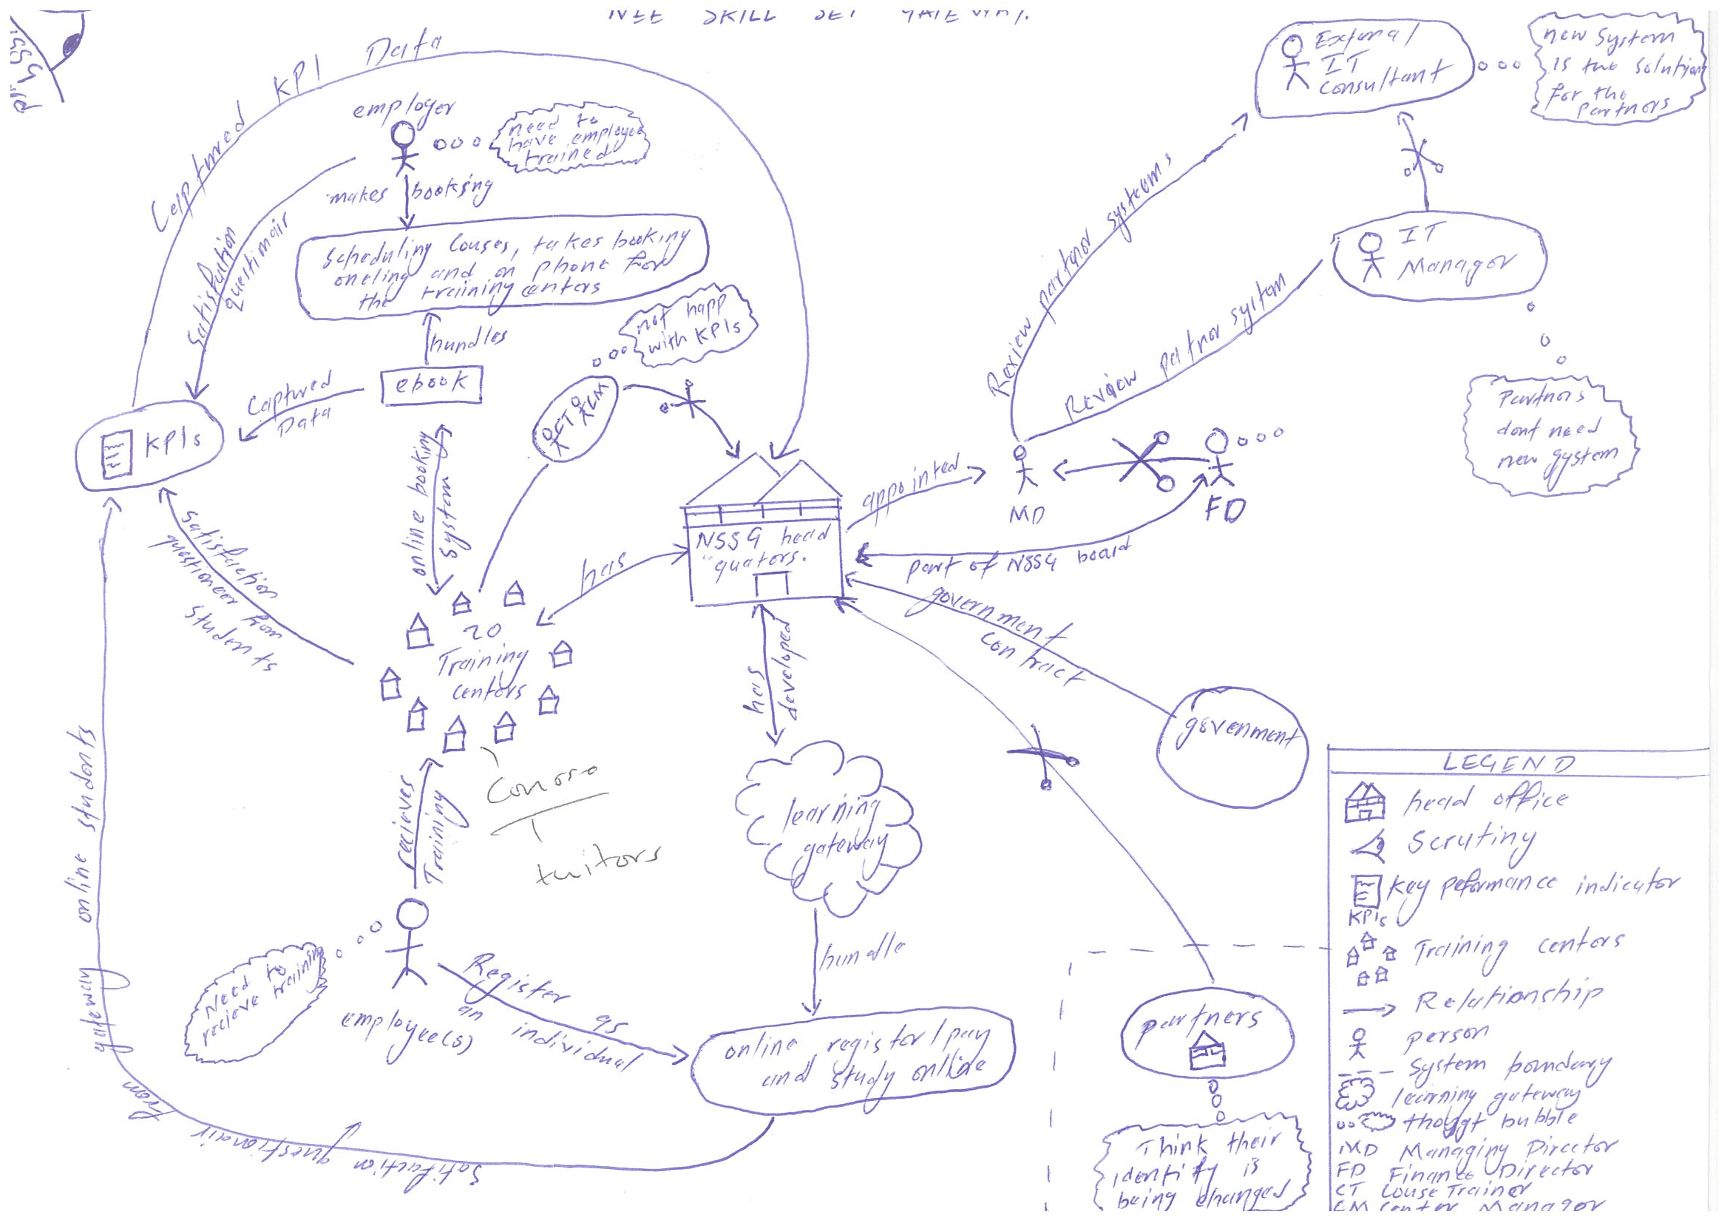

## A2. RICH PICTURE OF THE COMPLETE ELO ENVIRONMENT

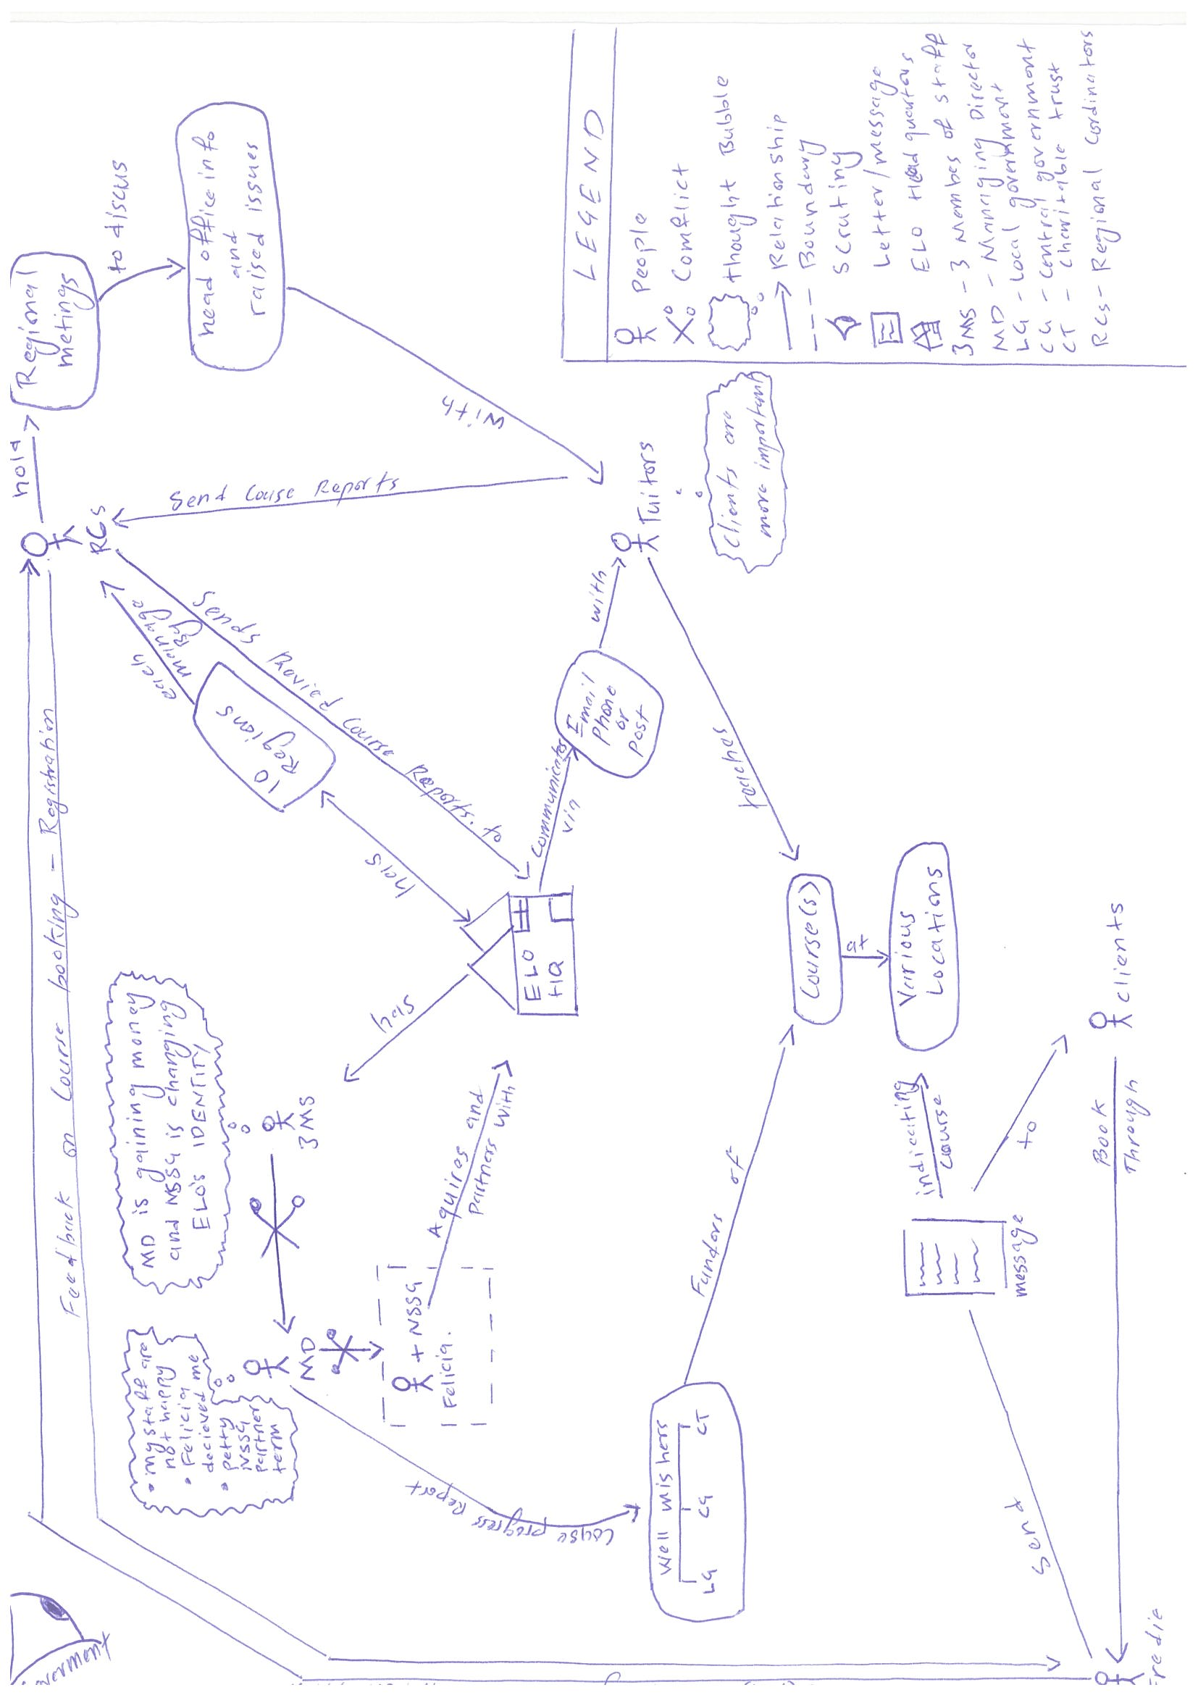

## A3. UNDERSTANDING OF NSSG OVERAL ENVIRONMET

### A3.1. KEY ACTORS

|  |  |
| --- | --- |
| **NSSG ENVIRONMENT** | |
| **ACTORS** | **ACTORS IMPACT ON ENVIRONMENT** |
| Managing Director - MD (Felicia Labelle) | Makes the most critical decisions for the company, is responsible for increasing company profits through partner companies via the government contract. |
| IT Manager - (Johnny Golding) | Responsible for ensuring that eBooks day today processes are maintained and is working according to its expectations and standards. Also responsible for reviewing partner system and solution to be taken |
| Course Trainer s – CT | Responsible for delivering the skills training at the different skills training centers |
| Trainer Center Manager – CM | Responsible for running and managing the day today affairs of the particular training center allocated to them. |
| External IT Consultant - (Hao Pun) | Responsible for Reviewing partner systems and building a new partner system that will be able to feed data into NSSG’s system eBook. |
| Finance Director - FD (Ken Wong) | Responsible for managing NSSG’s finances, profits and expenditures, also responsible for setting up a new financial system one that will enable NSSG account for all the funding received from the government. |
| Sales Staff | Responsible for running profit generating ventures for NSSG like taking phone calls from employers or other clients that wish to book a course. |
| Employer | Entitled to training services provided by NSSG be it that they are making a booking for themselves or for their employees |
| Employee | Entitled to receive services provided by NSSG be it at the training centers or using the learning gateways. |

### A3.2. KEY ISSUES AND AREAS OF CONFLICT

* The IT Manager is not in agreement with the introduction of a new system to be used by the partners. He suggested that the partners start using eBook as it will enable them to easily and efficiently schedule their course, take bookings online and on phone, take payments, register attendance and produce course certificates. However the Managing Director feels that the partners are illiterate to IT infrastructure and a system like eBook will be too much for them to manage. She further more contracted an External IT Consultant whose responsibility is to develop a new system that will be integrated into eBook and will be able to be used by the partners.
* NSSG board puts up measures to monitor performance of courses through key performance indicators (KPIs). Though this initiative has left the course trainers and training center managers unhappy as they feel that management does not understand the factors taken into consideration in order to deliver the courses and also feel that success or failure of a course is being evaluated on results and not the wider learning objectives.
* NSSG’s board is not as supportive as Felicia expected towards the government contract. They wish to continue working with the government sector only.
* Partners are becoming a bit hard to manage. Chris Paxton ELO’s MD feels that the introduction and change of their system to one that is brought about by NSSG makes him feel as if his company’s identity is being changed completely. They have been resistant to change and find no point in the KPIs and have no need for a new IT system.
* The finance director Ken Wong feels that a way in which partners collect their KPIs need to be sorted out. He feels that there is need for a justification in the way government funds are being spent on partner projects and feels that the setout targets for these projects are ridiculous and may be impossible to meet. He has gone on to show his dissatisfaction towards the decision made by Felicia and the board by describing it as a recipe for disaster.

The processes of collecting data from the KPIs are long and time consuming and on top of that a new financial system will need to be setup. Ken has shown is concern because setting it up is too costly meaning no profits will be generated from the “Looking Forward” program.

* External IT consultant Hoa Pun describes the looking forward project as one that could result in disaster and plans to leave once a new contract comes is way. This means that the only person Felicia expects to help her setup the Looking forwards project does not fully believe in its success and might leave as soon as a contract comes his way leaving Felicia at a disadvantaged position.

### A3.3. ORGANISATIONAL CULTURE AND SUB-CULTURES

As Felicia joins NSSG she brings about a culture where things are done in a completely new way. The culture with which she brings along with her is one that focuses on improving profits and raising the company’s profile nationwide by introducing cost efficiencies and expanding the business. Felicia convinces the board to introduce KPIs on courses and partners which poses a threat on long running cultures that have existed within the company and has led the course trainers and training center managers to be unhappy with the board’s decision because it change the order in which things are done. The IT manager prides himself on ebook a system the company has had running for a number of years now but with the new government contract and partnership with other organizations Felicia proposes that a new system be created which is to be used by the partners disregarding the IT managers advise of deploying ebook to be used by the partners. Having to do so brings about issues as far as the cost of the new system is concerned and this has put Felicia and the finance director in conflict because generating a new financial system in order to implement the partners system is a costly venture that might lead NSSG to not make any profit from the government tender.

### A3.4. MAIN FOCUS OF REQUIRED SYSTEM

NSSG’s partner organizations are illiterate to modern IT systems. A system like ebook would bring about more confusion within the partner organizations. A system that would be suitably developed for them is one that would help manage booking processes, the courses, registration and payments process and would in turn feed data into the main system ebook which at the end of it would produce a qualification processed and issued by NSSG as the main organization.

# PART B – REQUIREMENTS ANALYSIS USING USE CASE MODELLING

## B1. USE CASE DIAGRAM FOR ELO MANAGEMENT SYSTEM

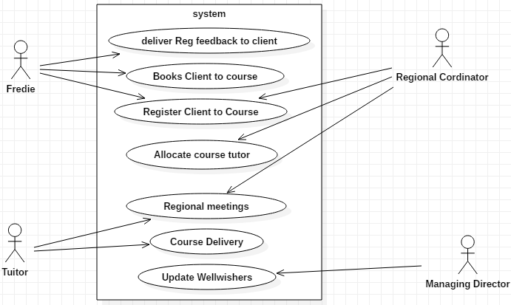

Figure3. ELO use case diagram

## B2. DOCUMENTING THE ELO USE CASE DIAGRAM

### B2.1. PRIMARY SCENARIOS

**Use case:** Deliver Registration feedback to client.

**Actor:** Freddie.

**Precondition:** sends client(s) booking and registration feedback with details on course venue.

**Flow of Events:**

* Freddie gets booking and registration approval from the regional coordinators.
* And send them to the clients.

**Post Condition:** Client is approved to take a course.

**Use case:** Book Client to course

**Actor:** Freddie

**Precondition:** Receive client information to be used to book them for a course

**Flow of Events:**

* Client(s) phone head office.
* Clients information such as client name, address and contact details is entered.

**Post Condition:** Course registration is usually done every three months. When a clients registers in advance there details are recorded in a spreadsheet but in the case where a client applies for a course that has already started the regional course coordinators are phoned/emailed and user information passed on to them.

**Use case:** Register Client to Course.

**Actor:** Freddie, Regional Coordinator(s).

**Precondition:** Receive Course details from clients.

**Flow of Events:**

* Enter course start date.
* Enter course end date.
* Enter course type.
* Enter course venue.

**Post Condition:** All course details are recorded in a spreadsheet.

**Use case:** Allocate course tutor

**Actor:** Regional Coordinators

**Precondition:** Each regional course coordinator manages a number of tutors within their region and assigns them to a course and venue based on what they are skilled or trained in.

**Flow of Events:**

* Issue list of questionnaires.
* Provide questionnaire feedback.
* Location of course.
* Courses start date.
* Send updated register in form of a spreadsheet.
* Gets course feedback at the end of every month

**Post Condition:** a course tutor is assigned and their responsibilities given.

**Use case:** Regional Meetings

**Actor:** Regional coordinator, tutor.

**Precondition:** regional coordinator meets all tutors in their regions

**Flow of Events:**

* Discuss information from the head office
* Raise issues to be resolved by the region or sent to the head quarters.

**Post Condition:** information passed from head office is discussed and issues are raised which are to be addressed.

**Use case:** Course delivery

**Actor:** Tutor

**Precondition:** teaches assigned course

**Flow of Events:**

* Delivers training to clients
* Review courses

**Post Condition:** training is provided to clients and course review used to come up with new courses.

**Use case:** Update well-wishers

**Actor:**  Managing Director

**Precondition:** In charge of day today running of ELO

**Flow of Events:**

* Giving performance reports to well-wishers.
* Managing terms of partnership with NSSG.

**Post Condition:** finale course performance reports are given and NSSG partnership finalized.

### B2.2. SECONDARY SCENARIOS

**Use case:** Deliver Registration feedback to client.

By examining the above use case, the following questions arise:

* What happens if feedback is not given?

By answering these questions, a secondary scenario for Deliver registration feedback to client use case is identified:

* Compare course register with registration spreadsheet.

**Primary and secondary scenario**

**Use case:** Deliver Registration feedback to client.

**Precondition:** sends client(s) booking and registration feedback with details on course venue.

**Flow of events:**

* Sending booking spreadsheet to the regional manager.
* Get feedback from the regional manager.
* Inform client about their booking and registration.

**Post Condition:** Clients get feedback about their booking and registration.

**Use case:** Book client to course

By examining the above use case, the following questions arise:

* What happens if client record already exists in the spreadsheet?
* What happens if client record does not exist in the spreadsheet?

By answering these questions, a secondary scenario for Book client to course use case is identified:

* Client record already exists in the spreadsheet.
* Enter client for the first time.

**Primary and secondary scenario**

**Use case:** Book client to course

**Precondition:** Receive client information to be used to register them for a course

**Flow of events:**

* Client call to make a course booking.
* Create a new client record in the spreadsheet if client does not exist.
* Enter clients information such as client name, address and contact details
* If client exists already confirm client detail.

**Post Condition:** client is recorded.

**Use case:** Register Client to Course.

By examining the above use case, the following questions arise:

* What happens if course does not exist?
* What happens if venue has been changed?

By answering these questions, a secondary scenario for Register Client to Course use case is identified:

* Register user to an existing course.
* Update client about changes in venue.

**Primary and secondary scenario**

**Use case:** Register Client to Course.

**Precondition:** Receive Course details from clients

**Flow of events:**

* Add the course to the spreadsheet if it does not exist.
* Advice client to pick another course.
* Enter new venue alongside the course.

**Post Condition:** client is registered to course.

**Use case:** Allocate course tutor

By examining the above use case, the following questions arise:

* What happens if assigned tutor is not available?
* What happen if tutor is not assigned a course?
* What happens if tutor is assigned to a wrong course?

By answering these questions, a secondary scenario for Assign course tutor use case is identified:

* Assign the next available tutor.
* Find and assign a course to tutor based on their recorded specification.
* Correct the spreadsheet and assign the tutor to their appropriate course.

**Primary and secondary scenario**

**Use case:** Assign course tutor

**Precondition:** Each regional course coordinator manages a number of tutors within their region and assigns them to a course and venue based on what they are skilled or trained in.

**Flow of events:**

* If the next available tutor is available, provide them with the appropriate course material and record their details in the spreadsheet.
* If the next available tutor is not available, assign the next available tutor to take up the course
* If tutor is not assigned a course, identify their specification and assign a course.
* Tutor who’s not assigned a course can also stand in as backup tutor or help out where needed.
* Record course and course details in a spreadsheet.
* Record tutor and tutor specification in a spreadsheet
* Relate tutor to specific course in the spreadsheet.

**Alternative solution:** inform clients in advance in the event that there is a discrepancy in the system and allocate alternative dates as quick as possible.

**Use case:** Regional Meetings

By examining the above use case, the following questions arise:

* What happens if meetings are cancelled?
* What happens if a tutor is not present?
* What happens to issues raised at regional meetings?

By answering these questions, a secondary scenario for Regional Meetings use case is identified:

* Reserve the next appropriate date to hold the meeting.
* Send tutor meeting notes at the end of the meeting.
* Issues raised are sent to head office for review.

**Primary and secondary scenario**

**Use case:** Regional Meetings

**Precondition:** regional coordinator meets all tutors in their regions

**Flow of events:**

* monthly update meetings are held by regional coordinator
* All tutors in a region attend regional meeting(s).
* Issues are raised and addressed appropriately.
* Information passed from head office is discussed.

**Post Condition:** Meetings are held by the regional coordinator to address all regional issues and needs.

**Use case:** Course Delivery

By examining the above use case, the following questions arise:

* How is course delivered?
* Where is course delivered?
* Who delivers a course?
* Who is the course delivered to?

By answering these questions, a secondary scenario for Course Delivery use case is identified:

* Delivered through teaching in classes.
* Various locations chosen by regional coordinators.
* Specialized tutor hired by ELO
* ELO clients.

**Primary and secondary scenario**

**Use case:** Course Delivery

**Precondition:** training is provided to clients and course review used to come up with new courses.

**Flow of events:**

* Tutors deliver course training.
* Tutors deliver course questionnaires.
* Tutors sums up clients performance at the end of course.
* Course is reviewed.

**Post Condition:** Clients receive course training.

**Use case:** Update well-wishers

By examining the above use case, the following questions arise:

* What happens if well-wishers are not updated

By answering these questions, a secondary scenario for Course Delivery use case is identified:

* Course Funds are pulled from ELO

**Primary and secondary scenario**

**Use case:** Update well-wishers

**Precondition:** Responsibility of managing director.

**Flow of events:**

* Generates course performance reports
* Sends course performance reports to funder/well-wishers.

**Post Condition:** MD is supposed to constantly send course performance reports if not funds for course are pulled.

## B3. DISCUSSING THE USE CASE MODELLING PROCESS.

The use case modeling process provides a more defined view to ELOs system. Developing the case study brought about an understanding of ELOs current system and its operations.

The use case diagram shows the actors that are involved in the day to day operations of ELOs system. During analysis which led to development of the case study, key actors with from within ELOs system where identified. In the use case diagram the listed key actors are Freddie, the regional course coordinators, the managing director and the tutors.

The scenario provides more actors than those represented in the use case diagram. This is because it is not all actors on the system that are main or rather key actors on the system. An analysis of clients shows that they are external system actors and are on the receiving end of the system. All they have to do is make a booking and the rest is provided to them free of charge.

Abstraction was applied in order for me to produce the use case diagram. I listed Freddie, the regional course coordinators, the managing director and course tutors as well as each one of their activities or roles on the system. Some of the activities are performed completely and fairly by a single actor while some of them are performed by more than one actor but all come together to complete all operations run on the system.

Having had an understanding of each key role played by an actor on the system, I was able to breakdown some of the key roles and expand them further as displayed in the secondary scenario. I came to understand that the system used by ELO is capable of handling more than it is able to handle but because it has been compressed and works in a way that suits the current IT illiterate employees, some of its key functionalities have been hidden and his not being used to its full potential. For example booking a client to a course in manually done, Freddie records the clients booking details and sends them to the regional course coordinators who in turn register the client to take part in the course. In the case that booking details are not sent, the client wouldn’t be registered to a course and feedback informing the client about their course registration would be delayed. An advance system would provide tool to update all the parties involved automatically and there would be less strain on the staff.

While developing the use case diagram, I made a few assumptions as to what some actor’s roles are on the system. I assumed that upon receiving a spreadsheet with all the clients booking details from Freddie the regional coordinators register clients and assign them to training centers depending on their location. I also assumed that the regional coordinators manage tutors and allocate a learning center for them to deliver the course or courses to the clients. I assumed that the course coordinators play a part in some of the administrative roles, bookings and finale review of tutor course review notes which they send to head office. I assumed that registration feedback sent to Freddie by the regional course coordinators has indicated, a course venue, course start date, course end date, course time and a course type.

On top of the assumptions that drawing the use case has brought about, it has also made me question some process within the ELO system and management.

Drawing the use case has made me question why ELO has delayed to setup a more sophisticated system, something that could work better than what they have and with some form of automation. What the new found partnership with NSSG will mean for their funders. Whether or not ELOs MD and staff will be answerable to Felicia’s demands and expectation. How they stand to gain from the government contract posed on them by NSSG. Why they are refusing a system that will be created for them to use without being charged anything.

The use case diagram and my further analysis of the scenario in the secondary scenario has made me question what ELOs plan for development is in the long run is and in the case where their funders feel dissatisfied with performance of the courses and pull funds, what is the way forwards for them.

In conclusion modeling the use case diagram has made me feel that ELO if NSSG government contract is successful will benefit greatly. The new system will enable them to efficiently manage their system with less error and automation of most system processes will lessen work load even on those members that are in conflict with the new system coming on board.

Partnership with NSSG will mean ELO will no longer be at constant threat of closing down when funders pull their funds because their courses will be sustained by NSSG.

# PART C – CRITIQUE OF USE CASES AND RICH PICTURES

RICH PICTURE

HOW IT HAS HELPED ME

A rich picture is an analytical tool that defines, acknowledges and explores a system through a diagram. Having to use a rich picture has given me a point of reference and a simplified understanding of both the NSSG system and the ELO system. It has helped me understand and demonstrate both system problems, activities, relationships and actors through a diagram.

As an analyst the rich picture has enabled me to understand the organizational cultures and sub-cultures that exist in both the organizations.

It simplified the way in which I analyzed the scenario as I went further in the course work. This was possible because it would direct me to an exact area and outlined the exact actions taking place in that area of the systems.

Having drawn NSSG and ELOs system from the bottom up has enable me to easily understand both systems areas of conflict, identify who the stakeholder are and what they expect from their respective system, identify relationship between the NSSG system and ELOs system and how a new system on ELO would be integrated and work for the better.

Rich pictures were a big advantage to me because it was easy for me to represent both NSSG and ELO systems. This was so easy to do because rich pictures do not require a lot of skill to draw. The fact that they don’t have a defined way of drawing them enabled me to draw the system according to the way I understood them.

STRENGTHS OF RICH PICTURES

* Anyone can use a rich picture to represent their system in its full depths listing all the components their system components.
* Because a rich picture is designed based on the analysts understanding of the system there are no special skills required in drawing them and do not require a lot of material to develop them.
* Problems within the system can be easily visualized and represented in a way that is very easy to understand.
* Participation of stakeholders makes it easy to understand the system and the needs of the stake holders at the end of it all.
* Rich pictures have a provision for a legend which is a key that explains all the components used to draw a rich picture hence making it easy to understand and read.

WEAKNESSES OF RICH PICTURES

* There are some components of a system or systems that are hard or cannot be represented visually
* Drawing a rich picture is time consuming and requires iterating through the process almost all the time
* Representing all the system elements, actors, perspective from all the stakeholders and relationships is a very difficult task to achieve.

USE CASE DIAGRAM

HOW IT HAS HELPED ME

Use cases have helped identify the key actors in both the NSSG system and the ELO system. it has given me an understanding of roles played by each actor be it, it is a joined by another actor or just done by a single actor. The use case diagram has helped in my analysis because it enabled be collect information about actors from the scenario which I future broke down into smaller and understandable information which can easily be used to develop the required system.

STRENGTHS OF USE CASE DIAGRAMES

* The simple and comprehensive summary of the system is provided in a single illustration
* Use case diagrams are easy to understand because they require narrative text
* Use case diagrams describe system problems from the onset hence saving analyst time that would be wasted trying to identify the problem.
* User case diagrams can be used to represent more than one world issue, can be used in different types of scenarios.

WEAKNESSES OF USE CASE DIAGRAMS

* It is not easy to use a use case diagram to capture non-functional requirements in a system build.
* Use cases require both developers and clients to learn them before they can understand them

COMMON THINGS ABOUT RICH PICTURES AND USE CASES.

* Both the rich picture and use cases take time to develop them
* Any approach can be used in accordance to user needs
* They are both complex approaches.